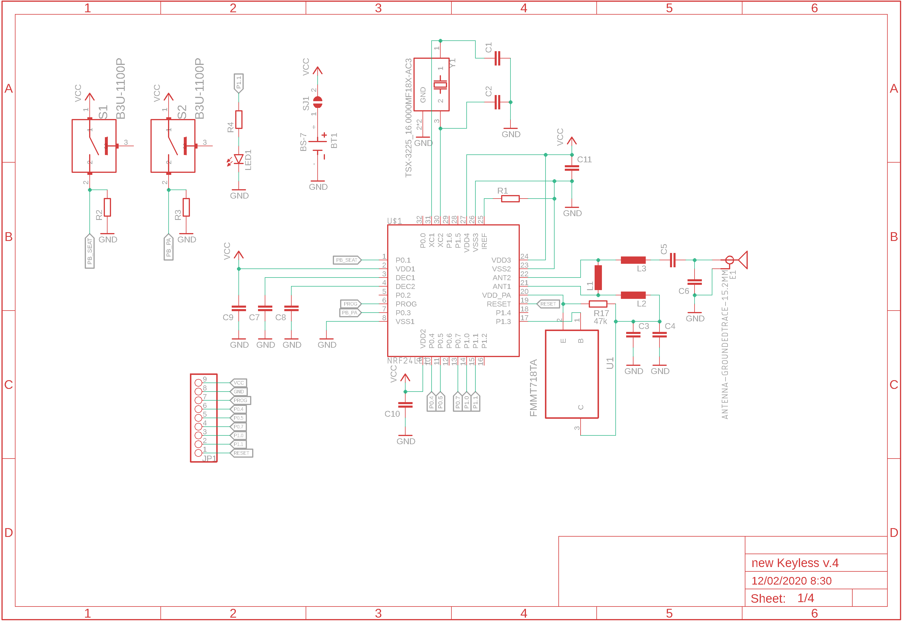

Pin for download the program

Transistor for connect and disconnect power amplifier

Battery

Push button